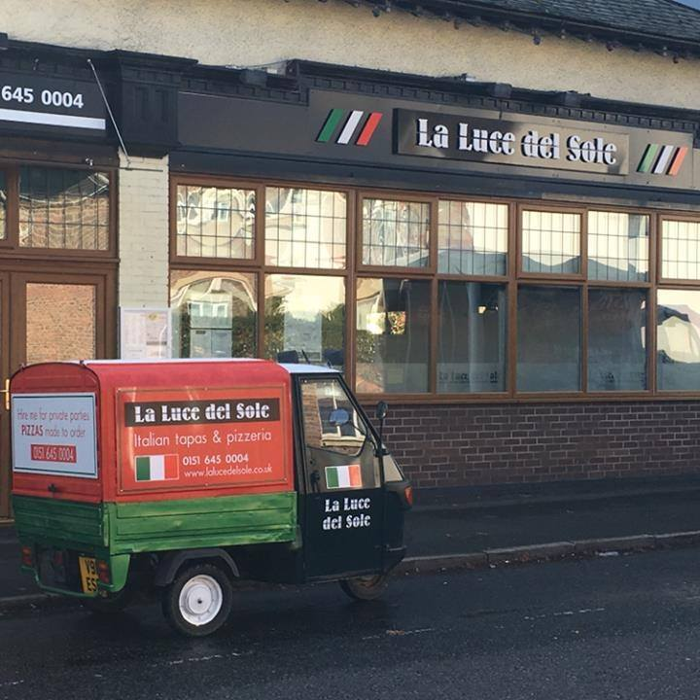
La Luce Del Sole Early Bird
3 Dishes for £12.00
Monday-Friday 4-6pm
Saturday & Sunday 12-6pm

Choose ONE from this selection

Patate e Aglio Mayo(V)
Potato chunks in galic mayo
Bruschetta al Pomodoro (V)
Tomato Bruschetta
Garlic Funghi (GF)(V) Garlic Mushrooms
Gnocchi con Funghi (V)
Fried Gnocchi in a creamy mushroom sauce
Palline di Algio (V)
Garlic Dough Balls
Hummus & Aritsan Bread (V)

Choose TWO from this selection

Arachini (V)
Mozzarella & Mushroom

Spiedini di Pollo (GF)
Chicken Skewers

Polette (GF)
Meatballs in Tomato Sauce

Le Costole del BBQ
BBQ Ribs
Calamari Fritti
Lemon & Black Pepper Calamari
Penne all’ Arrabiata(V)
Chilli, garlic & tomato

Spaghetti alla Carbanora (V)
Pancetta, Mushroom & Cream
Insalata di Casare (GF)(V)
Ceasar Salad with Anchovies
Insalta Caprese (GF)(V)
Buffalo Mozzarella & Cherry Tomato

Malanzane Parmigiana (V)

5’’ Margarita (V)

Lasagna

Aubergine Melanze

